About Use Cases

| Item | Explanation | Areas |
| --- | --- | --- |
| Login Details | * Just use emails + password | * Update Use Case Description * Update |
| Account Details | * To include display name | * Add Report Count |
| Bank Account Actor | * Scrap bank actor because too many things. |  |
| New Use Case: Chat Management : Create Chat |  |  |
| Delete AF for Accept Job and Request Service | Phone number no longer need to be verified. Because a logged in user implies that the phone number has been verified. |  |
| Question regarding GPS? | Have to enable GPS to | Just use dummy pop up window |
| Scrap the View Listing part for users who are not logged in |  | View Listing only allowed for logged in users. |
| Police | After Emergency Button | Both Ways |
| Customer Service | Add Secondary Actor | Both Ways |
| <use case> Rate User | After rated, they get the points immediately |  |
| <use case> Manage Points | Add, Deduct(when they claim something?), |  |
| Report | Escalate to customer support | Report count |
| Delete Complete Job as it has the same functionality as Update |  |  |
|  |  |  |

SGSECURE APP API everything also want to call police smh

Our current main functions:

1. Account Management: Login, Create Account
2. Chatting
3. Rating
4. Mahjong Points: Rewards System?
5. Report
6. Verification Using Phone Number
7. Call Police

Next meeting?: Monday 19/9 1630

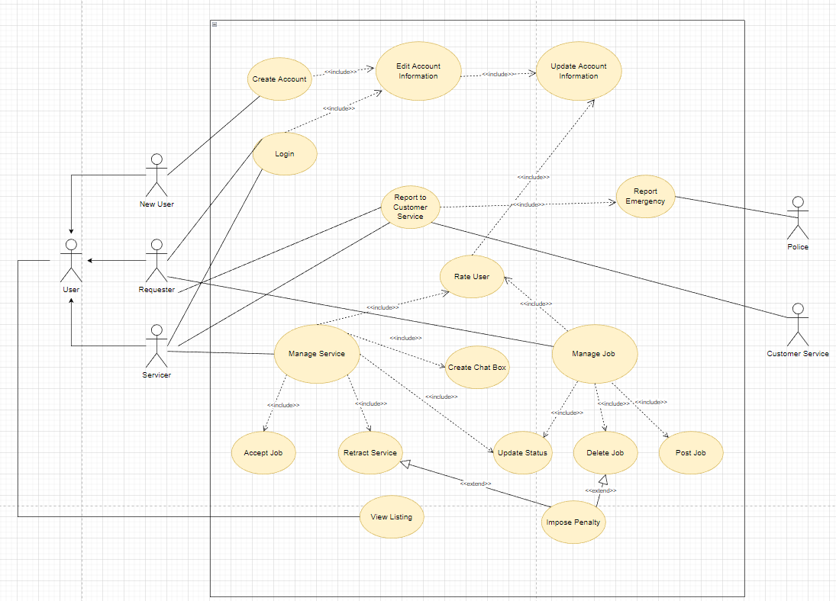

Idk why i cant export:

<maybe not working?>

1)<https://app.diagrams.net/#Wb!noAV-Tf6EkmE6O8M1B7uLeJgyaEir3dCoq57xWTZyEhV9IhqyUr2Ro8FRzdCSv5t%2F01WYDSRTD7U7SPOODNQBDKBNV6NAZR5G5W>

<WORKING> 2)<https://app.diagrams.net/#Wb!noAV-Tf6EkmE6O8M1B7uLeJgyaEir3dCoq57xWTZyEhV9IhqyUr2Ro8FRzdCSv5t%2F01WYDSRTFIRQF4KYUCE5CZ4ZWCZHKUTXRP>